
OPERATING SYSTEMS AND SYSTEMS PROGRAMMING (25CS2104E)
2026–27, Term-I
Project Problem Statement Submission Form
Section / Team Details
Section No.: 13
Team No.: 17
Project Title: Alarm Clock
Team Members
Roll Number | Student Name | Signature
2520090003 | S Udayasri
2520090014 | B Akshitha
2520090171 | R Bhanu Priya
1. Abstct
This project aims to design and implement a Linux-based Alarm Clock application using core Operating Systems and Systems Programming concepts. Traditional alarm applications rely on high-level frameworks, but this project focuses on building a lightweight command-line alarm utility using low-level system programming techniques available in Linux. The application allows users to set one or more alarms, after which the system continuously monitors the current time using system calls and triggers a notification through signal handling (SIGALRM) once the target time is reached.
Key concepts such as process/thread management, timers, signal handling, and file handling are used to implement alarm scheduling, background monitoring, and persistent storage of alarm data. The solution is implemented in C on a Linux/Ubuntu environment using POSIX APIs including alarm(), setitimer(), and pthread functions for concurrent execution. The expected outcome is a functional command-line alarm clock capable of setting, storing, and triggering multiple alarms reliably.
2. Problem Statement
Most desktop and mobile alarm applications are built using high-level GUI frameworks that abstract away the underlying Operating System mechanisms used to track and trigger time-based events. This makes it difficult to understand how an operating system actually manages timers, signals, and background processes at the system level. There is a need for a simple, Linux-based alarm clock utility that directly uses OS-level APIs and system calls to schedule and trigger alarms, demonstrating practical applications of process management, signal handling, and system programming concepts.
3. Objectives
1. To design a Linux-based command-line alarm clock application using C and POSIX system calls.
2. To implement alarm scheduling and triggering using timers and signal handling (SIGALRM).
3. To enable persistent storage and retrieval of alarm settings using file handling.
4. To demonstrate the use of multithreading for continuous background monitoring of alarm times.
4. Proposed Methodology
The application will be developed in C on a Linux/Ubuntu environment. When the user sets an alarm through the command-line interface, the alarm time is stored in a local file for persistence. A background thread, created using the pthread library, continuously monitors the system time using time-related system calls and compares it with the stored alarm time.
Once the current time matches the alarm time, a SIGALRM signal is generated to alert the user through a console notification. The setitimer()/alarm() system calls manage precise timing, while nanosleep() avoids busy-waiting and reduces CPU usage. The modular design separates alarm-setting, monitoring, and notification into distinct functions for clarity and maintainability.
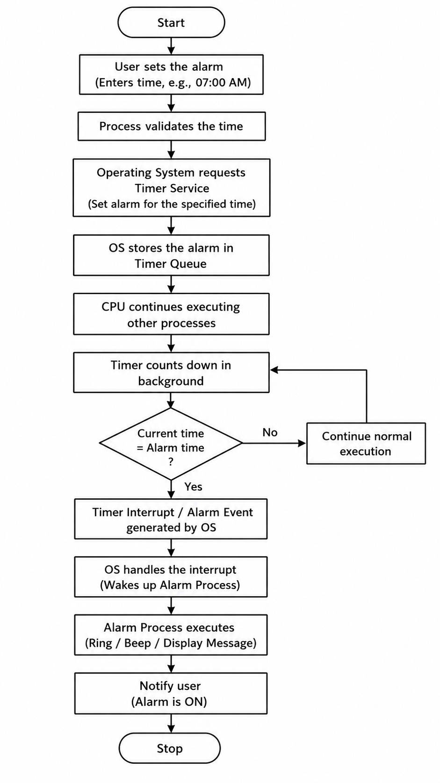
5. Operating Systems Concepts / Linux APIs Used
OS Concept / Linux API / System Call | Purpose in the Project
Signals (SIGALRM) | To trigger the alarm event at the specified time
alarm() / setitimer() system calls | To schedule and generate timed interrupts for the alarm
POSIX Threads (pthread_create) | To run the alarm-monitoring routine concurrently with the main program
File I/O (open, read, write) | To store and retrieve saved alarm settings from a file
nanosleep() | To implement precise time delays while checking for the alarm time
Process scheduling / sleep() | To keep the alarm-monitoring process running with minimal CPU usage
6. Individual Contribution
Roll Number | Student Name | Individual Responsibility
2520090003 | S Udayasri | Design and implementation of the alarm-triggering logic using signals and system calls
2520090014 | B Akshitha | Development and testing of the alarm-setting interface and background monitoring thread
2520090171 | R Bhanu Priya | Implementation of alarm data storage/retrieval using file handling, and documentation

7. Tools / Platforms / Software Used
Tool / Platform / Software | Purpose
Linux / Ubuntu | Development and testing platform for the alarm clock application
C / C++ | Core language used to implement timer logic and system calls
GCC / Make | Compiling and building the source code
POSIX Threads (pthread) library | Managing the concurrent alarm-monitoring thread
VS Code / gedit | Code editing and debugging

8. Expected Outcome
The expected outcome of this project is a fully functional Linux-based Alarm Clock application capable of setting, storing, and managing multiple alarms through a command-line interface.
The application will accurately trigger alarms at the specified time using signal handling and system calls, while efficiently using system resources through proper use of threads and sleep/timer mechanisms. The project will also provide hands-on understanding of key Operating Systems concepts such as process scheduling, inter-process communication, and system-level time management.
9. GitHub Repository
GitHub Repository Link: https://github.com/udayasri-21/OSSP_PROJECT
Repository Created: Yes
☐ Yes ☐ No

Faculty Name and Signature
Faculty Name: S Alekhya
Signature: ______________________________________________________________
Remarks: ______________________________________________________________________

----------------------------------------------------------------------------------------------------------------------------

Faculty Use
Project Approved: Yes
☐ Yes ☐ No
Date: _________________________________________________________________
Faculty Signature: _____________________________________________

